**Engineering Mechanics**

**Professor Manoj K Harbola**

**Department of Physics**

**Indian Institute of Technology Kanpur**

**Module 1**

**Lecture No 07**

**Kronecker Delta and Levi-Civita symbols-I**

So far we have looked at vector operations like vector sum, subtracting a vector from another vector, and product of vectors. In this lecture, we are going to look at how symbolically right in a very compact way and I am going to introduce something called the δ function

(Refer Slide Time: 0:38)

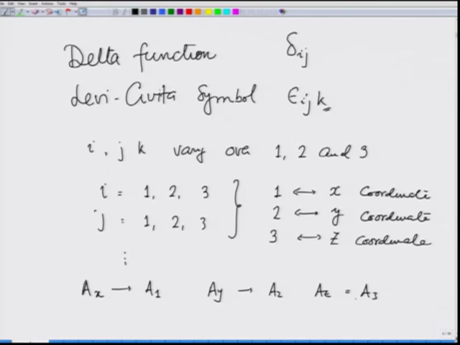

and Levi-Civita symbol. This I am going to denote as δ ij and this I am going to denote as ijk where i, j or k vary over 1, 2 and 3. That means i could take values 1, 2 or 3, j could take values 1, 2 and 3 and so on. So any any subscript that I use here can take values 1, 2, and 3 and we are going to denote 1 we are going to use 1 for x coordinate, 2 for y coordinate and 3 for z coordinate.

So just to make you familiar, for example I am going to write Ax for a vector as A1, Ay as A2 and Az as A3. Writing in terms of 1, 2 and 3 makes life easy when we want to express quantities in a compact form.

(Refer Slide Time: 2:18)

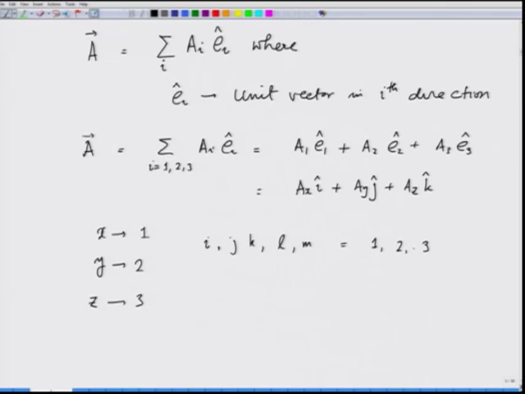

So for example vector A then could be written as summation i Ai ei where ei is unit vector in i-th direction. So you can see that if I expand it, it will be summation i varies from 1, 2, 3 Ai ei and that becomes A1 e1 plus A2 e2 plus A3 e3 which when translated into our regular language of x, y and z it will become Ax i plus Ay j plus Az k. So this is just getting used to it that I am going to denote x as 1 I am repeating it, y as 2 and z as 3.

And any symbol subscript i, j, k, l, m, all of these very over 1, 2 and 3. So let me now introduce the δ symbol and Levi-Civita symbol.

(Refer Slide Time: 3:48)

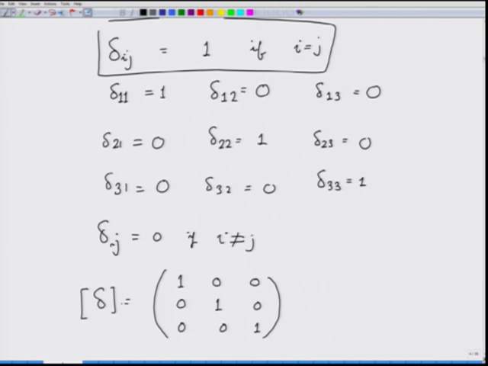

1st the δ symbol. δij is going to be defined as it is going to be 1 if i equals j. That means δ11 is 1, δ12 we will see, δ 1 3 we will see what it is, δ22 is 1, δ33 is 1, δ23, δ21 and δ31, δ32. So this part we have taken care of by writing δ11 equals 1, δ22 equals 1, δ33 equals 1. And if δij is equal to 0, if i is not equal to j.

And therefore, all these terms are going to be 0. If I were to represent this δ symbol as a matrix, it is going to be 1, 0, 0, 0, 1, 0, 0, 0, 1. This is δ matrix if you like. So this is an identity matrix. How does it help?

(Refer Slide Time: 5:11)

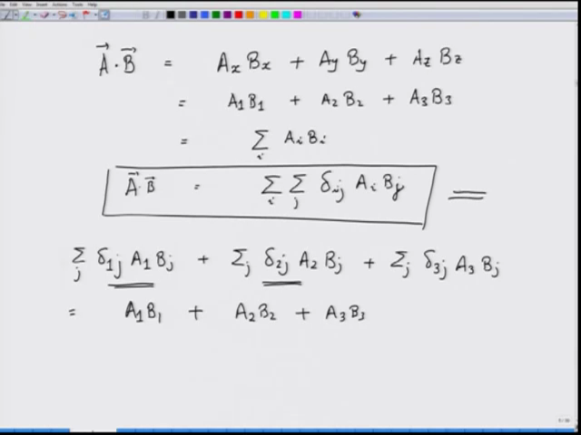

Let us look at that now. If I take A dot B, recall from earlier exercises or earlier lectures that this is nothing but Ax Bx plus Ay By plus Az Bz which I can write as A1 B1 in our new notation plus A2 B2 plus A3 B3 which I can also write as summation i Ai Bi. And in terms of δ symbol I can write this as summation over i summation over j δij Ai Bj.

So this is A dot B. You can very easily see that it actually is the same thing as Ax Bx plus Ay By plus Az Bz. Let us do that just to get more familiar with it. So I have summation over j δ 1 j A1 Bj plus i is 2. So that is going to be summation over j δ2j A2 Bj plus summation over j i equals 3 δ3j A3 Bj. When j is one, I get δ 1 1 in the 1st term. Let us look at this term, j is 1, I get 1.